**IZZA SALES SQL QUERIES**

1. **KPI’S**

**TOTAL REVENUE:**

SELECT SUM(total_price) as "Total Revenue"

FROM pizza_sales;

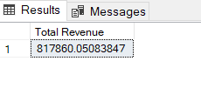

**AVERAGE ORDER VALUE:**

SELECT SUM(total_price)/COUNT(DISTINCT order_id) as "AVERAGE ORDER VALUE"

FROM pizza_sales;

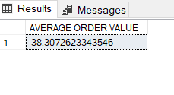

**TOTAL PIZZAS SALES:**

SELECT SUM(quantity) as "TOTAL PIZZA SALES"

FROM pizza_sales;

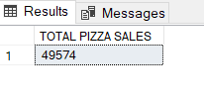

**TOTAL ORDERS:**

SELECT COUNT(DISTINCT order_id) as "Total Orders

FROM pizza_sales;

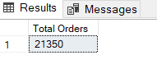

**AVERAGE PIZZAS PER ORDER:**

SELECT CAST(CAST(SUM(quantity) AS decimal(10,2))/CAST(COUNT(DISTINCT order_id) AS decimal(10,2) )as decimal(10,2) ) as "AVERAGE PIZZA PER ORDER"

FROM pizza_sales;

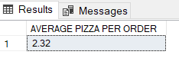

1. **CHARTS DATA**

**DAILY TRENDS FOR TOTAL ORDER:**

SELECT DATENAME(weekday,order_date) as "DAYS", COUNT(DISTINCT order_id) AS “DAILY COUNT”

FROM pizza_sales

GROUP BY DATENAME(weekday,order_date);

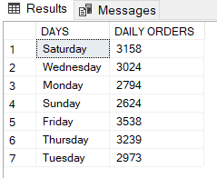

**MONTHLY TRENDS FOR TOTAL ORDER:**

SELECT DATENAME(MONTH,order_date) as "MONTHLY", COUNT(DISTINCT order_id) AS "MONTHLY ORDERS"

FROM pizza_sales

GROUP BY DATENAME(MONTH,order_date)

ORDER BY [MONTHLY ORDERS] DESC;

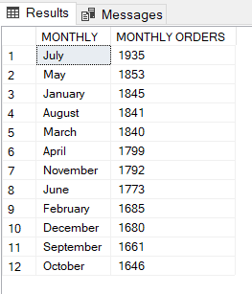

**PERCENTAGE OF PIZZA SALES BY CATEGORY:**

SELECT pizza_category,SUM(total_price) AS "TOTAL REVENUE FROM EACH CATEGORY",SUM(total_price)*100/(SELECT SUM(total_price) FROM pizza_sales) AS "PERCENTAGE"

FROM pizza_sales

GROUP BY pizza_category;

SELECT pizza_category,SUM(total_price) AS "TOTAL REVENUE FROM EACH CATEGORY",SUM(total_price)*100/(SELECT SUM(total_price) FROM pizza_sales WHERE MONTH(order_date)=1) AS "PERCENTAGE"

FROM pizza_sales

WHERE MONTH(order_date)=1

GROUP BY pizza_category; ###FOR JANUARY ONLY

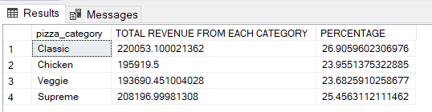

**PERCENTAGE OF PIZZA SALES BY SIZE:**

SELECT pizza_size,CAST(SUM(total_price) AS DECIMAL(10,2)) AS "TOTAL REVENUE FROM EACH SIZE",CAST(SUM(total_price)*100/(SELECT SUM(total_price) FROM pizza_sales) AS DECIMAL(10,2)) AS "PERCENTAGE"

FROM pizza_sales

GROUP BY pizza_size;

SELECT pizza_size,CAST(SUM(total_price) AS DECIMAL(10,2)) AS "TOTAL REVENUE FROM EACH SIZE",CAST(SUM(total_price)*100/(SELECT SUM(total_price) FROM pizza_sales WHERE DATEPART(quarter,order_date)=1) AS DECIMAL(10,2)) AS "PERCENTAGE"

FROM pizza_sales

WHERE DATEPART(quarter,order_date)=1

GROUP BY pizza_size; #for one quarter jan to march

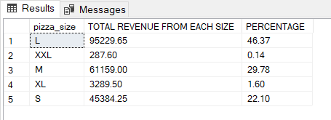

**TOP 5 PIZZA BY REVENUE:**

SELECT TOP 5 pizza_name,sum(total_price) AS"TOTAL REVENUE"

FROM pizza_sales

GROUP BY pizza_name

ORDER BY sum(total_price) DESC; ### only the top 5 by revenue

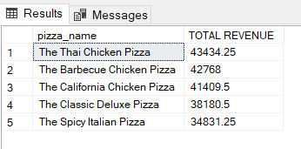

**BOTTOM 5 PIZZA BY REVENUE:**

SELECT TOP 5 pizza_name,CAST(sum(total_price) AS DECIMAL(10,2))AS"TOTAL REVENUE"

FROM pizza_sales

GROUP BY pizza_name

ORDER BY sum(total_price); ### only the Bottom 5 by revenue

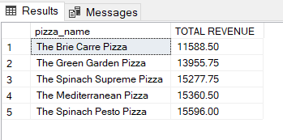

**TOP 5 PIZZA BY QUANTITY:**

SELECT TOP 5 pizza_name,sum(quantity)AS"TOTAL REVENUE"

FROM pizza_sales

GROUP BY pizza_name

ORDER BY sum(quantity) DESC;

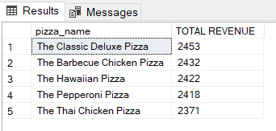

**BOTTOM 5 PIZZA BY QUANTITY:**

SELECT TOP 5 pizza_name,sum(quantity)AS"TOTAL REVENUE"

FROM pizza_sales

GROUP BY pizza_name

ORDER BY sum(quantity);

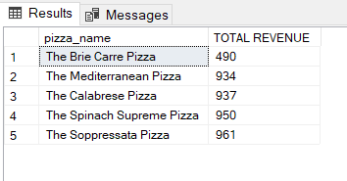

**TOP 5 PIZZA BY ORDERS:**

SELECT TOP 5 pizza_name,COUNT(DISTINCT order_id)AS"TOTAL ORDERS"

FROM pizza_sales

GROUP BY pizza_name

ORDER BY [TOTAL ORDERS] DESC;

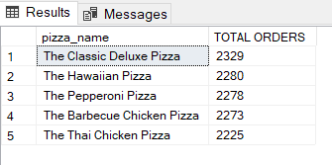

**BOTTOM 5 PIZZA BY ORDERS:**

SELECT TOP 5 pizza_name,COUNT(DISTINCT order_id)AS"TOTAL ORDERS"

FROM pizza_sales

GROUP BY pizza_name

ORDER BY [TOTAL ORDERS];

